Welcome to the Procare Mobile App
Your All-in-One App for Staying Connected with Your Individual’s Day and Services

Dear Families, Guardians, Case Managers, and Residential Providers,
We’re excited to share that PAI now uses Procare, a secure communication app designed to help you stay connected and informed about your individual’s day and services.
With Procare, you can:
- View daily activity summaries and daily notes.
- See arrival and departure times.
- Receive program newsletters – weekly programming plans, event reminders, and team notifications (unexpected closures, etc.)

Learn more here!
Getting Started is Easy!
- Create Your Account
You’ll receive an email from Procare at connect-hello@online.procaresoftware.com. Follow the link provided to set up your login. If you already have a Procare account, you can log in with your existing credentials.

- Download the Procare App
Apple App Store (iOS)
Google Play (Android)

- Log In & Explore
Use your email and password to sign in. Start viewing updates.

For a step-by-step video of getting started steps, click here. For more helpful tips and information, visit the resource page here.

Need more help? PAI is here to help support you!
In-person and virtual help sessions:
  - Thursday, April 9th, 3:00pm-4:30pm @ PAI Parkway
4453 White Bear Parkway, White Bear Lake, MN 55110

  - Friday, April 10th, 10am-11am Virtual
Meeting Link: https://teams.microsoft.com/meet/29405770750888?p=cG9GAV5BPPdsqec6J1

  - Tuesday, April 14th, 5:30pm-6:30pm @ PAI Linden
3595 Linden Ave, White Bear Lake, MN 55110
  - Wednesday, April 15th, 10:00am-11:30am @ PAI Linden
3595 Linden Ave, White Bear Lake, MN 55110
  - Friday, April 17th, 2pm-3pm Virtual
Meeting Link: https://teams.microsoft.com/meet/27411924940383?p=rrCahq7HqBPpCO3emd

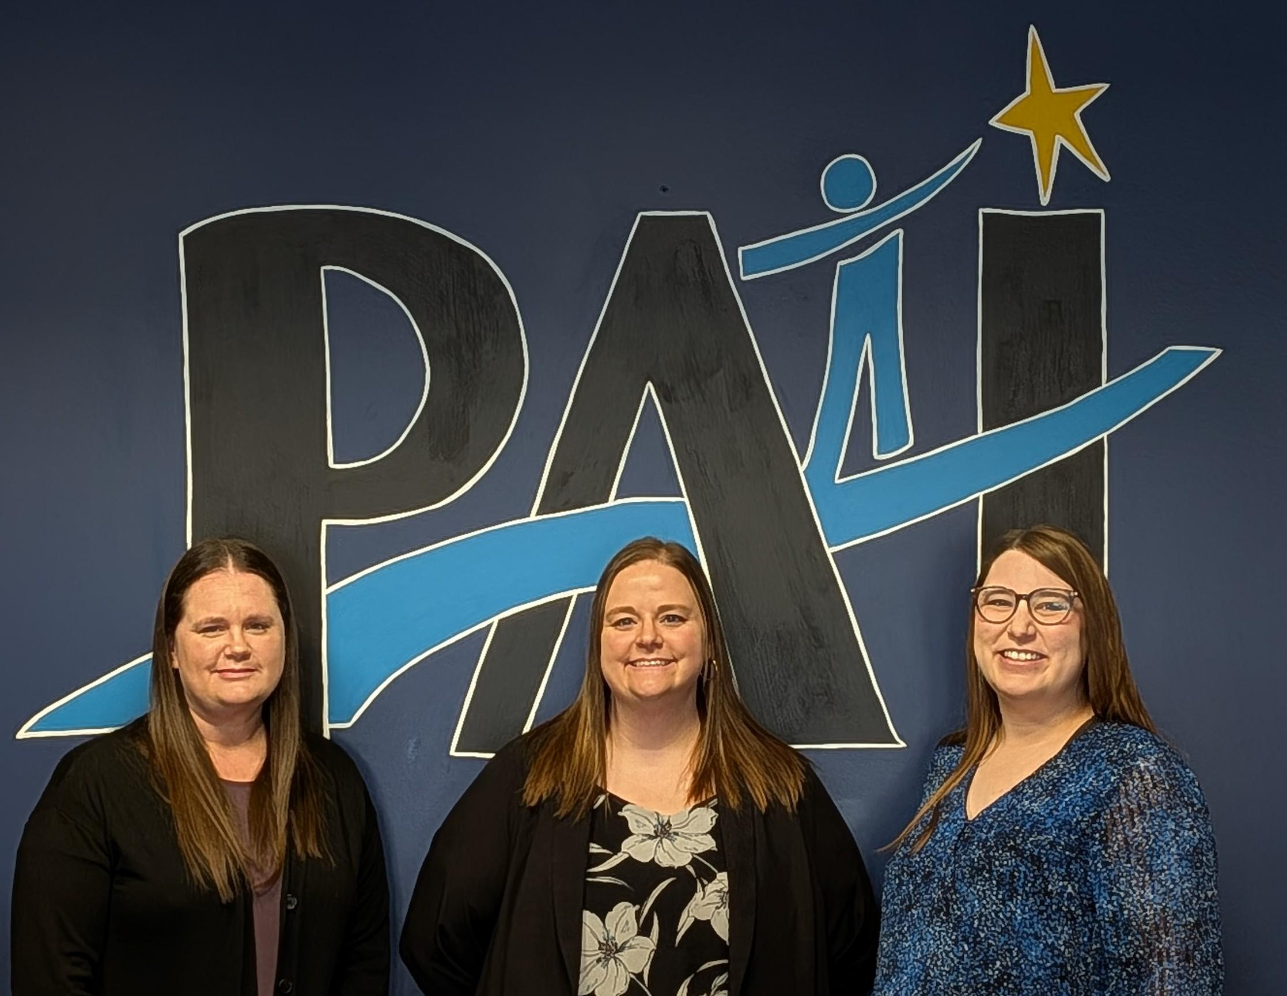
Cortney Kelly, Senior Program Director of Commerce & Parkway
Email: ckelly@paimn.org
Phone: 612-446-3497

Kennedy Smith, Program Director of Linden & Oakdale
Email: ksmith@paimn.org
Phone: 612-446-3687

Sarah Lentz, Associate Program Director of Employment Service & In Home Supports & Respite
Email: slentz@paimn.org
Phone: 612-446-3697
*Please note that Sarah will be on medical leave effective on or before April 10th, 2026*

